**Python Coding Challenge**

**Q1)**

**(i)Explain Pandas for Data Processing & execute Reading CSV Data using Pandas**

**(ii)Read Data from CSV Files to Pandas Dataframes.**

**(iii)Filter Data in Pandas Dataframe using query.**

**SOLUTION:**

**(i)Pandas:** It is a library in Python used for data manipulation and analysis.  it offers data structures and operations for manipulating numerical tables and time series. The primary data structures in Pandas are the DataFrame and Series.

* **DataFrame:** A DataFrame is a two-dimensional, tabular data structure resembling a spreadsheet or SQL table.
* **Series**: A Series is a one-dimensional labelled array capable of holding any data type.

**Reading CSV Data Using Pandas**

**The CSV file:**

**Code in Python to Read the CSV file using Python**

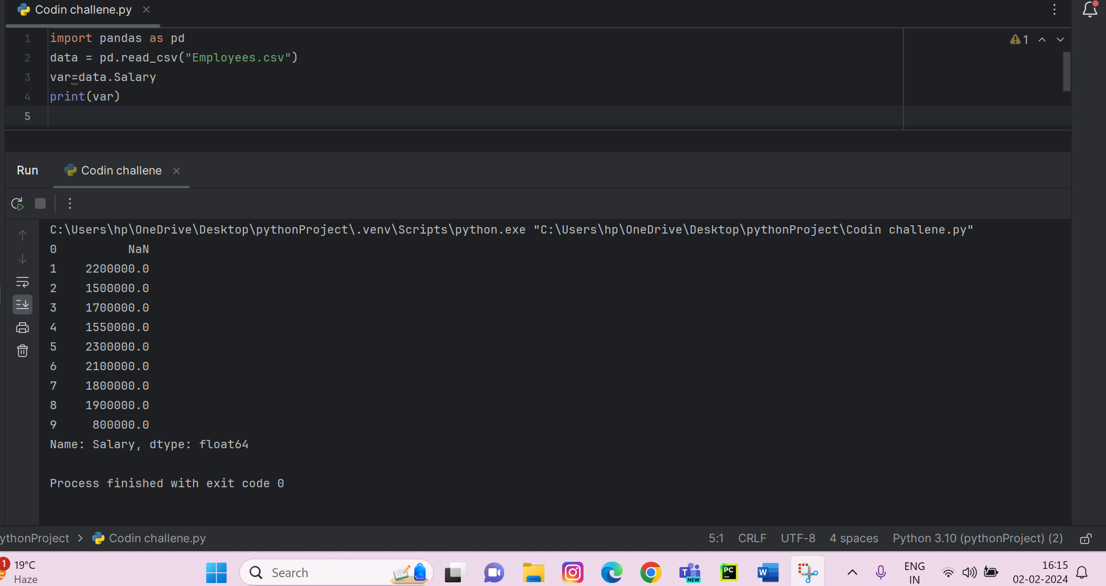

**(ii)Read Data from CSV Files to Pandas Dataframes**

* **Using head()**

* **Using describe()**

**(iii)Filter Data in Pandas Dataframe using query.**

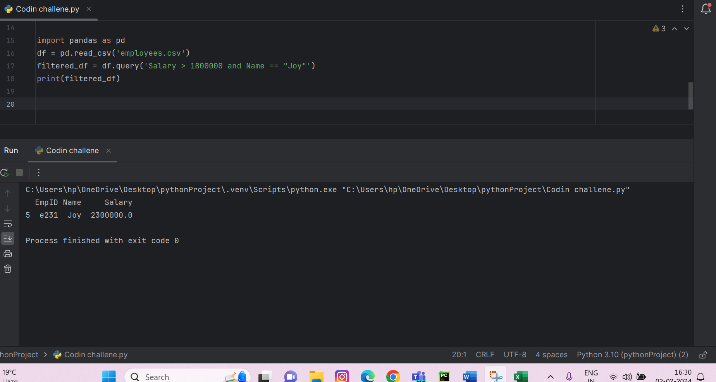

**Another Example Of Filtering data based on the Average Salary**

